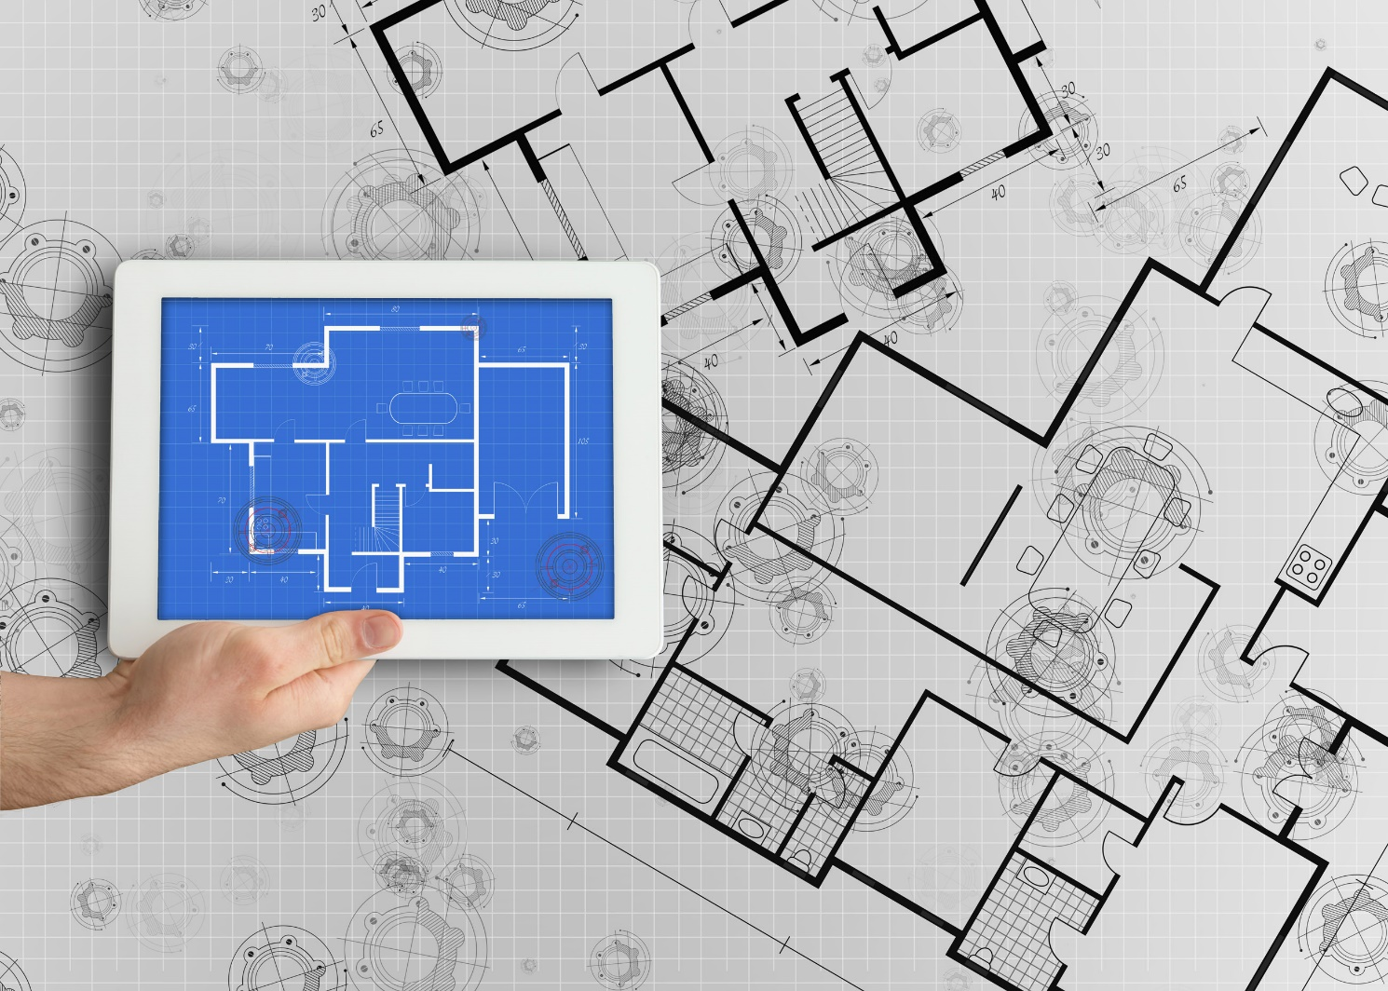
wi

Nufarm - Integrated Seller Transaction Guideline
August 2017

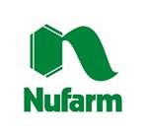
Table of Contents
Version History 3
Nufarm Mapping Requirements and Deltas 4
Nufarm Detailed Specifications and Requirements 5
Scope 5
Purchase Order Details 5
Order Confirmation Details 6
Ship Notice Details 6
Invoice Details 6
Supplemental Documentation 9
Ariba Network Support Information 10

Version History
This log is updated each time this Process Document is updated. The log identifies the version number, the date the version was completed, the author of the changes, and a brief description of the changes.

Version | Date | Author | Description
1.0 | 10/08/2017 | Aleks Spirkoski  Ariba, an SAP Company | Initial Version of Document
1.1 | 21/09/2017 | Aleks Spirkoski  Ariba, an SAP Company | Added accepted units of measure
SAP STATEMENT OF CONFIDENTIALITY AND EXCEPTIONS
The contents of this document shall remain the confidential property of SAP and may not be communicated to any other party without the prior written approval of SAP. This document must not be reproduced in whole or in part. It must not be used other than for evaluation purposes only, except with the prior written consent of SAP and then only on condition that SAP’s and any other copyright notices are included in such reproduction. No information as to the contents or subject matter of this proposal or any part shall be given or communicated in any manner whatsoever to any third party without the prior written consent of SAP.
The furnishing of this document is subject to contract and shall not be construed as an offer or as constituting a binding agreement on the part of SAP to enter into any relationship. SAP provides this document as guidance only to estimate costs and time-scales of the predicted delivery project. This will be subject to confirmation prior to any contractual or delivery commitment by SAP.
SAP warrants that to the best of its knowledge those who prepared this material have taken all reasonable care in preparing it and believe its contents to be true as at the date of this document. SAP cannot however warrant the truth of matters outside of its control and accordingly does not warrant the truth of all statements set out in this document to extent that such statements derive from facts and matters supplied by other persons to SAP. The statements in this document are qualified accordingly.

Nufarm Mapping Requirements and Deltas

Deltas
In the following excel workbooks you will find baseline cXML transactions accepted by the Ariba Network with the additional requirements for Nufarm noted in red.

cXML Delta:
The following is a summary of the requirements that are unique to Nufarm’s procurement environment, as detailed in the Excel Delta’s document.
Purchase Order Specifics (Tab 1)
- Payment terms will be sent on all POs and are not required back on the Invoice
- PO will contain ShipTo ID(each ID corresponding to a unique address), list of all addresses provided below

Invoice Specifics (Tab 2)
- Required addresses and IDs: Remit To Address with supplier TaxID/ ABN
- Non-PO invoices are supported but each Non-PO invoice must contain order information (sales order number, Contract number, etc)
- Payment terms value cannot be changed as it appears on the PO. The value should be read from the PO and returned on the Invoice

Order Confirmation Specifics (Tab 3)

Ship Notice Specifics (Tab 4)

Extrinsics (Tab 5)

Transaction Validation Rules

Please note, Nufarm has configured custom validation rules on the Ariba Network which apply specifically to POs, Order Confirmations, Ship Notices, Service Entry Sheets, PO based Invoices, and non-PO based Invoices. Review these settings from your supplier account on the Ariba Network.

Nufarm Detailed Specifications and Requirements

Scope

Nufarm Prod ANID: AN01052089903
Nufarm Test ANID: AN01052089903-T

Required Transactions
  - Purchase Order
  - Invoice

Optional Transactions
  - Order Confirmation
  - Advanced Ship Notice

Purchase Order Details

Purchase Order Types Supported | Purchase Order Types Not Supported
New POs | Blanket POs (BPO’s)
Change/cancel POs | Service POs
Non-catalog POs
POs with attachments
Table 1 - Purchase Order Types Supported/Not Supported

Ship To Address

  - Nufarm PO will send Ship To address at header level
  - Nufarm PO will not contain Ship To address IDs

ShipToID’s can be located in the “UniqueName” column within the attachment below:

Order Confirmation Details

Nufarm does not require Order Confirmation. Supported methods of providing them are:
  - cXML
  - Online

Ship Notice Details

Nufarm does not require Advanced Ship Notices. Supported methods of providing them are:
  - cXML
  - Online

Invoice Details

Invoice Types Supported | Invoice Types Not Supported
Individual Detail Invoice: applies against a single PO referencing line items; line items may be material items or service items. | Invoice against Blanket PO
Partial invoice: Invoice against a portion of the items on a PO. | Line level credit supported by negative quantity at item level and positive unit price
Invoice against material PO | Invoice against PCard
Invoice against service PO | Header Invoice: single invoice applying to single PO without item details
Non-PO Invoice: invoice against PO not transacted via the Ariba Network
Non-PO invoice against contract or master agreement
lineLevelCreditMemo (cXML 1.2.018 and higher) invoice purpose set to “lineLevelCreditMemo”
Header Credit Memo and Debit Memo
Cancel Invoice
Duplicate Invoice: invoice numbers may be reuse in case where the original invoice has failed
Table 2 - Invoice Types Supported/Not Supported

Tax Requirements

- Tax is supported at the line level or summary level or both.

Remit To Address Information
  - Remit To address information is required on the Invoice and must include supplier entity’s ABN/TaxID as indicated below.

  - <InvoicePartner>
  - <Contact role = "remitTo">
  - <Name xml:lang = "en-US">Test SupplierName>
  - <PostalAddress>
  - <Street>20 GILCHRIST DR</Street>
  - <City>LIVERPOOL</City>
  - <State>NSW</State>
  - <PostalCode>2560</PostalCode>
  - <Country isoCountryCode = "AU">AU</Country>
  - </PostalAddress>
  - </Contact>
  - <IdReference domain = "supplierTaxID" identifier = "123123123"/>
</InvoicePartner>

Shipping and Special Handling Fees

  - Shipping and special handling charges are supported at the line level or summary level or both.

Non-PO Specific Invoice Requirements

- PO number, Sales Order number, or Contract number is required.

Contract Invoice Specific Requirements

  - Sold To contact – Provided by Nufarm on request
  - Accounting Information such as GL Code and Cost centre – Provided by Nufarm on request

Line Level Validation
- The following line level data cannot be changed from PO to Invoice.
  - Currency for Unit Price
  - Unit Price (allowed if within a 5% tolerance)
  - Unit of Measure
  - Item Quantity Overage
  - Part Number

Accepted Units of Measure
- The below UOM are expected by Nufarm ERP

Supplemental Documentation

This document contains Nufarm specific information regarding transaction requirements. Information in this document does NOT cover the complete technical aspects of integrating with the Ariba Network. Below are two sections for supplemental documentation to be used with this document for EDI or cXML transaction formats. Only refer to the section that pertains to the format your organization with be sending/receiving from the Ariba Network (EDI or cXML).

cXML Section for Supplemental Documentation
New cXML supplier to Ariba Network must:
- Support a DTD (document type definition) validation tool internally and download the document type definitions (DTD’s) for all supported transactions.
- Support HTTPS protocol. Ariba supports HTTPS (not HTTP) only for cXML transactions.
- Review the cXML Solutions Guide and cXML User Guides.
cXML Document Type Definitions (DTD’s):
- http://cxml.org Download InvoiceDetail.zip for the InvoiceDetailRequest.dtd.
- http://cxml.org Download cXML.DTD for the OrderRequest
- http://cxml.org Download Fulfill.dtd for ConfirmationRequest/ShipNoticeRequest

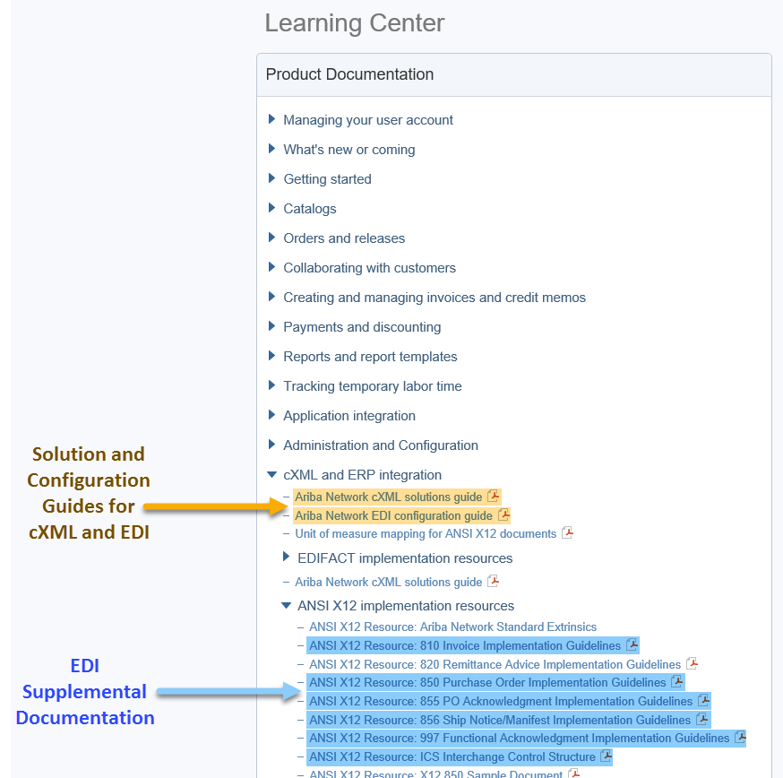
Recommended Resources: Please log into your supplier account on the Ariba Network in order to access the cXML and EDI solution and configuration guides as well as supplemental EDI documentation. The steps for accessing this information is outlined below.

- Log into your supplier account on the Ariba Network.
https://supplier.ariba.com
- Select Help Center >>
- Select Documentation
- Expand cXML and ERP Integration

Within the cXML and ERP Integration section, you will see the cXML and EDI solution and configuration guides. Based on your selected integration method, please download the appropriate document.
- Ariba cXML Solutions Guide
- Ariba Network EDI Configuration Guide

Supplemental EDI Documentation
To access the supplementation EDI documentation, proceed to step 5.
- Expand ANSI X12 implementation resources

Within the ANSI X12 implementation resources section, you will find supplemental EDI documentation for the following EDI documents:
- 850 Purchase Order Implementation Guidelines
- 810 Invoice Implementation Guidelines
- 855 PO Acknowledgment Implementation Guidelines
- 856 Ship Notice/Manifest Implementation Guidelines
- 997 Functional Acknowledgment Implementation Guidelines
- ICS Interchange Control Structure (Ariba Production and Test Interchange ID Details)

Ariba Network Support Information

Supplier Integration (SI) support is available to Nufarm suppliers. SI support is available during the test phase and two weeks post-go live with Nufarm, or until the first production transactions are exchanged. After that period, suppliers must leverage Ariba Technical Support for any production issues. To contact SI support, send an email to askaribatech@ariba.com. Be sure to list Nufarm in the subject line of the email.
Depending on your transaction volume across all Buyers on the Ariba Network you will be automatically subscribed to a Supplier Membership Program Subscription. These subscriptions provide your organization access to many premium features and services that are exclusively available to members at these levels. The Premier, Enterprise, and Enterprise Plus levels provide ongoing technical electronic document support. To find out more go to:
http://www.ariba.com/assets/uploads/documents/Datasheets/SMP_Subscription_Datasheet.pdf.
To find out your Program Subscription, log on to https://supplier.ariba.com, click the Property Navigator toolbar on the upper right corner of the page and select Service Subscriptions in the drop down box.
Until subscribed to one of Ariba’s support programs, limited assistance regarding account registration, access and configuration is available from Ariba:

By Web:

If you can log into your Ariba Network Account | If you cannot log into your account
- Login at http://supplier.ariba.com  - Once logged in, click on the ‘Help’ link located on the upper right hand side of the page and choose Help Center.  - Select Support located in the top right hand side of the page.  - Options in the bottom right hand side of the page are Live Chat or By Phone.  - An Online Service Request can also be submitted by selecting the “Start” button in the top center of the page. | - Go to http://supplier.ariba.com  - For login issues select the “Forgot Username” or “Forgot Password” links near the top of the page.  - Fill out the web form and select the Submit button.

